AI-BASED SMART TRAFFIC MANAGEMENT
Design and Implementation
Department of Computer Science and Engineering, TKR College of Engineering & Technology
Batch A10 (CSE-A) · Academic year [ACADEMIC YEAR]
Table 1: Project team
S.No. | Student name | Roll number
1 | Buneti Harshitha | 23K91A0548
2 | Bhuvaneshwari Kadike | 23K91A0537
3 | Ambati Sai Nikhil Reddy | 23K91A0510
4 | Chapala Rohith Reddy | 23K91A0551

Project guide: Laxmi Prasanna
Chapter and section numbers quoted in the text (for example Chapter 8 or Section 6.2) refer to the full project report, 17.Final Document. Figures and tables in this document are numbered from 1.

1. DESIGN
This chapter describes how FlowSense is built: the architecture and workflow, the data flow, the class and sequence design, the data design, the three core algorithms, the module and API design and the user interface. Every diagram was drawn from the code (smart_traffic/sim.py, predictor.py, vision.py and the backend/ package) and is reproduced with an explanation; the full set is also collected in the Block Diagrams document.

1.1 Design Goals and Architecture
Five goals shaped the design. First, like-for-like comparison: every controller must face exactly the same vehicles, the same ambulances and the same red-light runners, otherwise a difference in delay could come from luck rather than from the controller. This is why the simulator draws demand from a seeded random generator that the controllers never touch. Second, one pipeline rather than parts: the literature survey found systems that either detect vehicles or adapt signal timing but not both [2], [3], so FlowSense keeps vision, forecasting, control, emergency priority and violation logging in one code base. Third, measurable behaviour: every claim is checked by an experiment that can be re-run from scripts/run_experiments.py. Fourth, runnable on a laptop without a GPU or a traffic simulator licence, which led to a pure-Python simulator instead of SUMO [24]. Fifth, a console that an operator can read: live map, benchmark, vision, prediction and violation screens, each driven by the real engine.
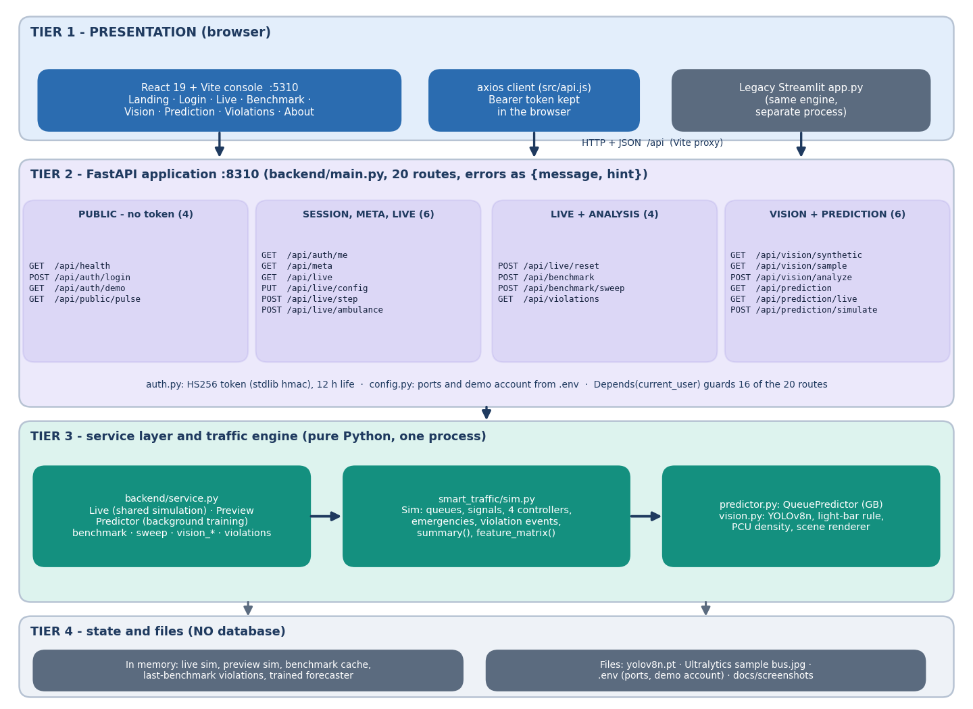
Figure 1: Four-tier architecture of FlowSense: presentation (React console, axios client, legacy Streamlit app), FastAPI application with 20 routes, service layer and traffic engine, and in-memory state and files (no database).
The presentation tier is a React 19 and Vite console on port 5310 that calls the API through a Vite proxy. The application tier is FastAPI on 127.0.0.1:8310 with four route groups: public routes (health, login, demo account, landing-page pulse), the live-control routes, the benchmark and sweep routes, and the vision, prediction and violation routes. A service layer in backend/service.py wraps the engine and holds the shared state: one live simulation, one background-trained queue forecaster, a benchmark cache and the landing-page preview simulation. The engine itself, in smart_traffic/, has three modules: the simulator and its four controllers, the forecaster, and the vision layer. Nothing is stored on disk except model weights for YOLOv8 (yolov8n.pt) and the experiment outputs; there is no database, so everything held in memory is lost when the API restarts.
The original Streamlit application (app.py) was kept unchanged beside the new web console. Both call the same engine functions, which is why the engine contains no web code and the service layer contains no traffic logic.

1.2 High-Level Workflow
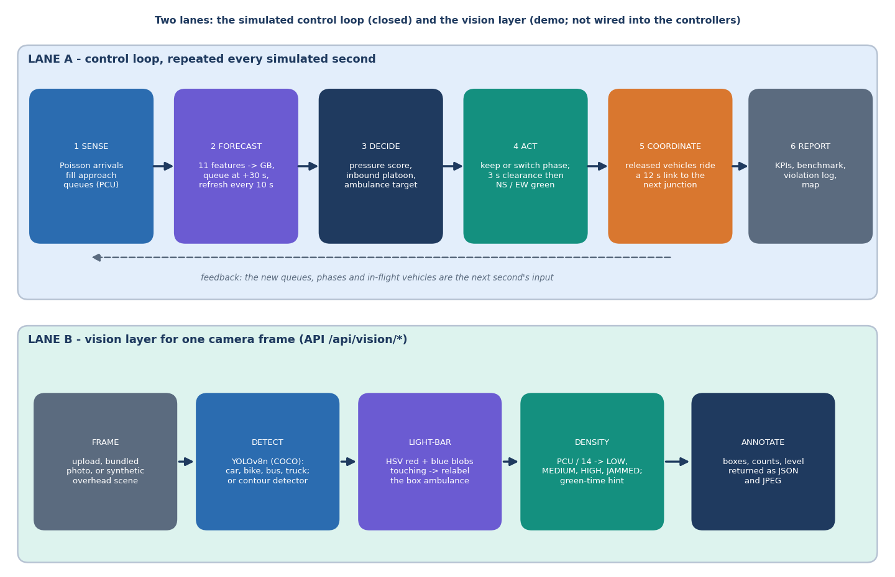
Figure 2: High-level workflow: Lane A is the closed control loop repeated every simulated second; Lane B is the vision layer for one camera frame (a demo path, not wired into the controllers).
The workflow has two lanes. Lane A is the control loop, run once per simulated second in six steps. Sense: Poisson arrivals fill the approach queues, measured in passenger-car units. Forecast: eleven features per approach go into the gradient-boosted model, which predicts the queue 30 seconds ahead and is refreshed every 10 seconds. Decide: each junction computes its pressure score (queue, forecast excess, inbound platoon, fairness) and looks for an ambulance target. Act: the junction keeps or switches its phase, with a 3-second clearance before the new green. Coordinate: vehicles released by one junction ride a 12-second link and appear in the next junction's inbound scan, and an ambulance within 15 seconds of a junction makes it switch ahead of time, which produces a green wave. Report: the KPIs, benchmark tables, violation log and map are served to the console. The new queues, phases and in-flight vehicles are the next second's input.
Lane B is the vision layer for one camera frame. The frame (an upload, the bundled photograph or a synthetic overhead scene) goes to a detector (YOLOv8n or the contour detector), the light-bar rule relabels a vehicle box as an ambulance, the density step turns counts into passenger-car units, a level and a green-time hint, and the annotated image and numbers are returned as JSON. This lane informs the operator on the Vision screen; the simulator's controllers do not call it, and that distinction matters when reading the results.

1.3 Data Flow Diagrams

1.3.1 Level 0: context
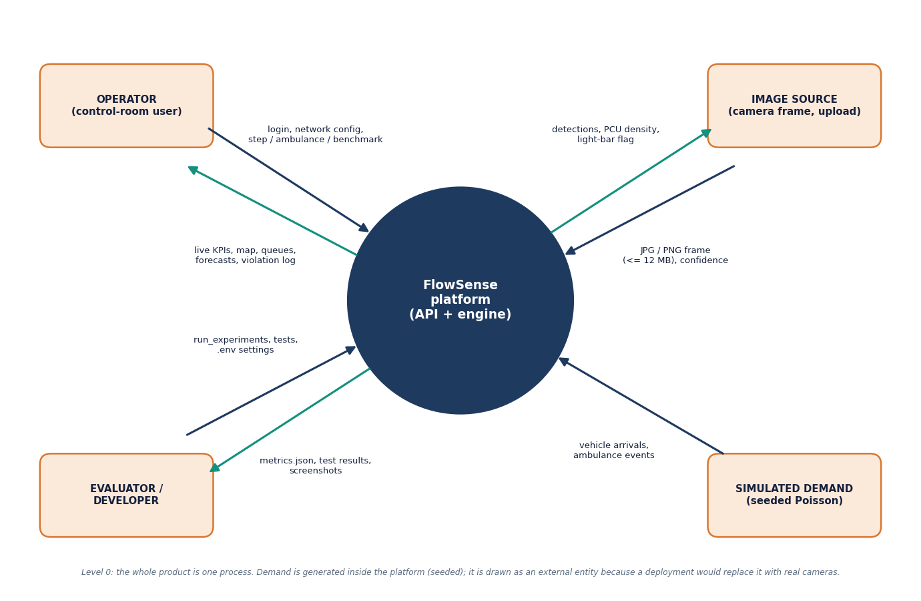
Figure 3: Data flow diagram, level 0: four external entities exchange data with the FlowSense platform.
At level 0 the platform is a single process with four external entities. The operator sends the login, the network configuration (grid, controller, demand, emergency toggle, ML toggle) and commands (step, ambulance, benchmark) and receives live KPIs, the map, queues, forecasts and the violation log. The image source (a camera frame or an upload of up to 12 MB) sends a JPG or PNG with a confidence threshold and receives detections, the PCU density and the light-bar flag. The evaluator or developer supplies .env settings and runs the experiment, test and screenshot scripts, receiving metrics.json files, test results and screenshots. Simulated demand (seeded Poisson arrivals and ambulance events) is drawn as an external entity although it is generated inside the platform, because a deployment would replace it with real cameras.

1.3.2 Level 1: seven processes
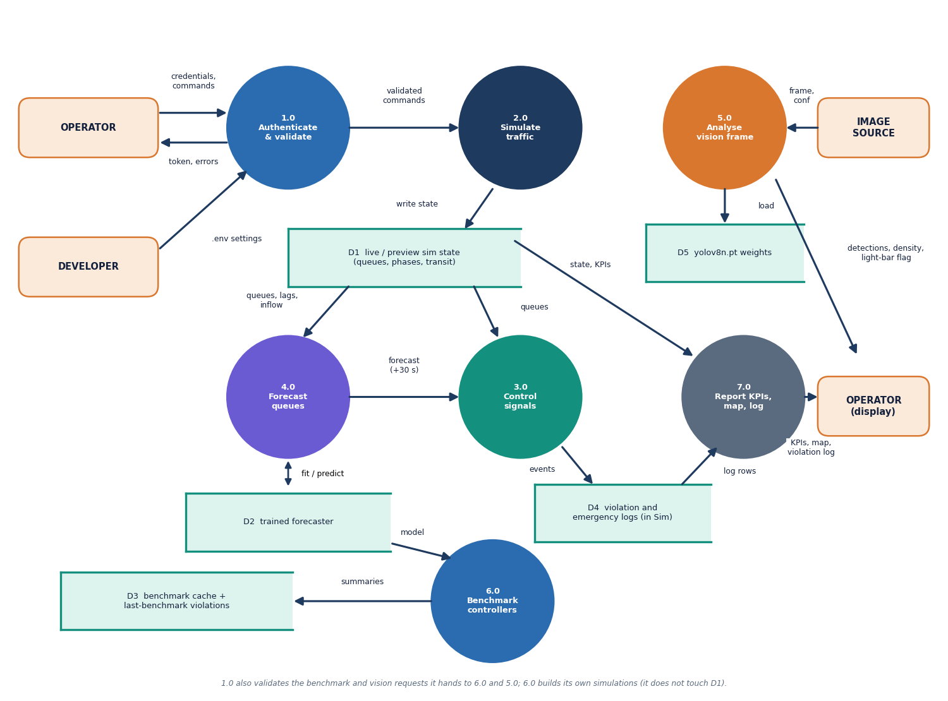
Figure 4: Data flow diagram, level 1: seven processes and five data stores.
Level 1 divides the platform into seven processes. 1.0 Authenticate and validate checks credentials and tokens against the .env settings and validates the requests it passes on. 2.0 Simulate traffic advances the network and writes its state to store D1 (live and preview simulation state: queues, phases, transit). 3.0 Control signals reads the queues and the forecast and writes events (violations, emergencies) to D4. 4.0 Forecast queues reads queues, lags and inflow from D1, fits and reads the model in D2 and returns a 30-second forecast to 3.0. 5.0 Analyse vision frame loads the YOLOv8n weights (D5) and returns detections, density and the light-bar flag. 6.0 Benchmark controllers builds its own simulations with the model from D2 and stores summaries in D3, the benchmark cache with the last benchmark's violation counts; it never touches D1. 7.0 Report KPIs, map and log reads D1 and D4 and returns the display to the operator. The public landing preview is a second simulation held in the same store as D1 so that it never disturbs an operator's session. All five stores except the weights file are memory structures.

1.3.3 Level 2: one simulated second
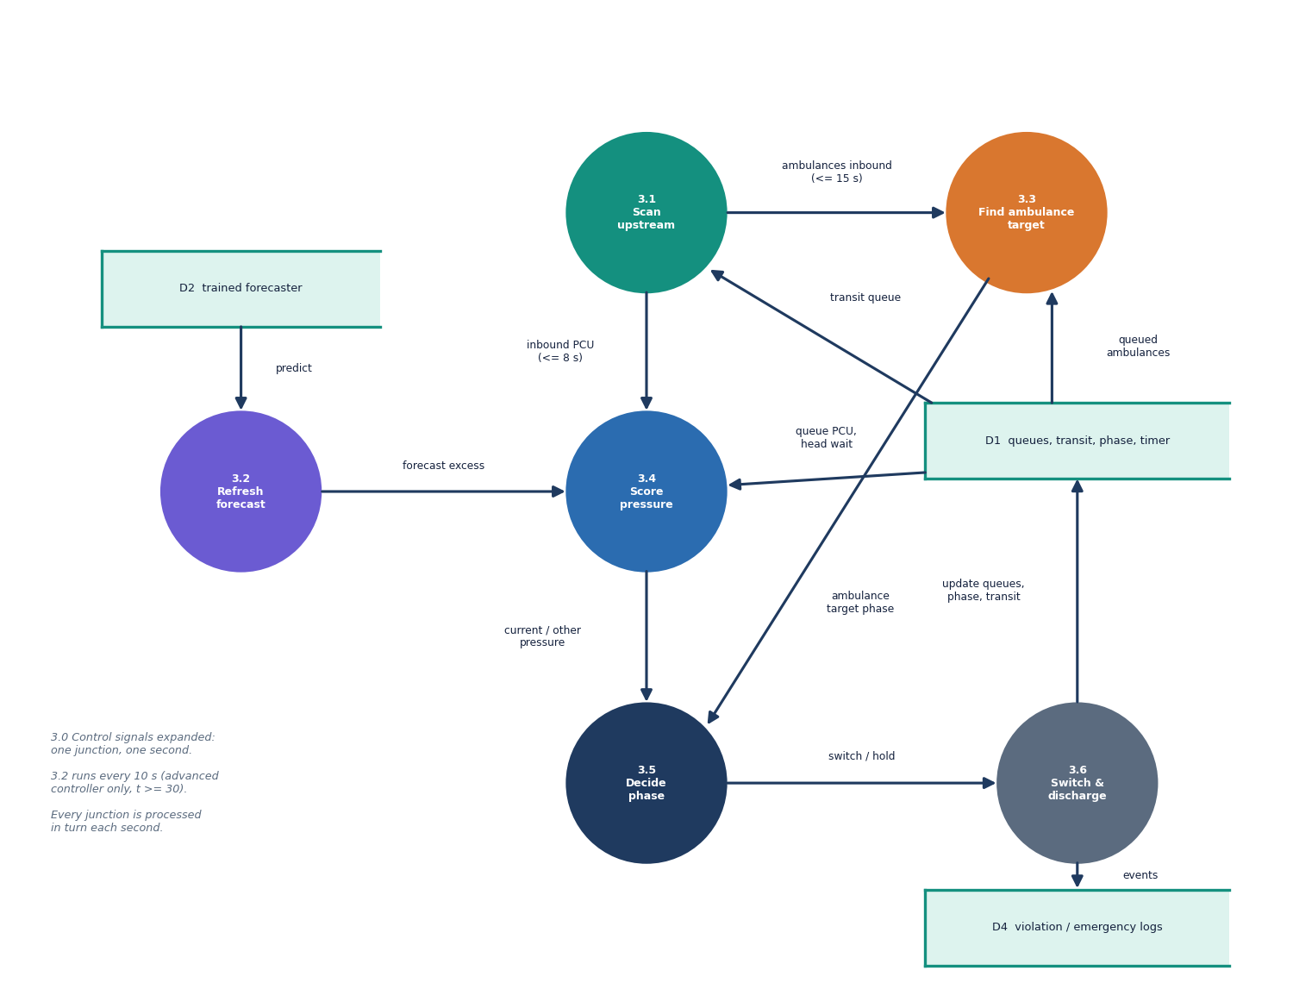
Figure 5: Data flow diagram, level 2: process 3.0 (control signals) expanded into six sub-processes for one junction and one second.
Level 2 expands the control process for one junction in one second. 3.1 Scan upstream reads the transit queue and produces the inbound PCU within 8 seconds and the ambulances inbound within 15. 3.2 Refresh forecast (advanced controller only, every 10 seconds from t = 30) obtains the model's prediction from D2. 3.3 Find ambulance target combines the queued ambulances in D1 with the inbound ones to name the phase of the nearest ambulance. 3.4 Score pressure combines queue PCU, forecast excess, inbound PCU and head wait for the current and the other phase. 3.5 Decide phase applies the minimum-green, maximum-green and pressure rules, or the ambulance target, and outputs switch or hold. 3.6 Switch and discharge updates queues, phase and transit in D1 and writes events to D4. The five steps of the whole simulated second are tabulated in Section 5.6.4.

1.4 UML Design

1.4.1 Class diagram
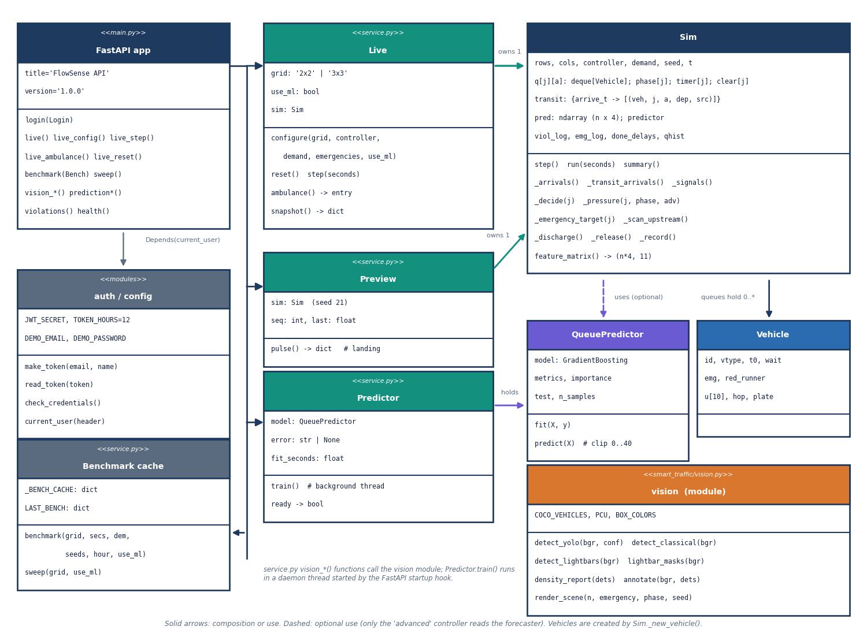
Figure 6: UML class diagram: the FastAPI application, the service classes, the simulator, the forecaster and the vision functions.
Table 2: Principal classes and their roles.
Class | File | Role
Sim | smart_traffic/sim.py | The network: queues, phases, timers, transit list, controllers, KPIs, violation and emergency logs; step, run, feature_matrix, summary
Vehicle | smart_traffic/sim.py | One vehicle: id, type, arrival time, accumulated wait, emergency flag, red-runner flag, route draws, plate
QueuePredictor | smart_traffic/predictor.py | Gradient-boosted regressor with Random Forest and persistence baselines; fit, predict, metrics, importance
Live | backend/service.py | The shared live simulation: configure, step, reset, ambulance, snapshot
Preview | backend/service.py | The landing page's own real-time simulation and event lines
Predictor | backend/service.py | Background training wrapper with ready and error state
ApiError | backend/service.py | Exception carrying status, message and hint, rendered as JSON

Sim is deliberately large because the four controllers differ only in _signals and _decide; everything else (arrivals, transit, discharge, recording) is shared, which is what guarantees identical demand. The vision layer is a module of functions rather than classes because each call is a pure transformation of an image.

1.4.2 Sequence diagram
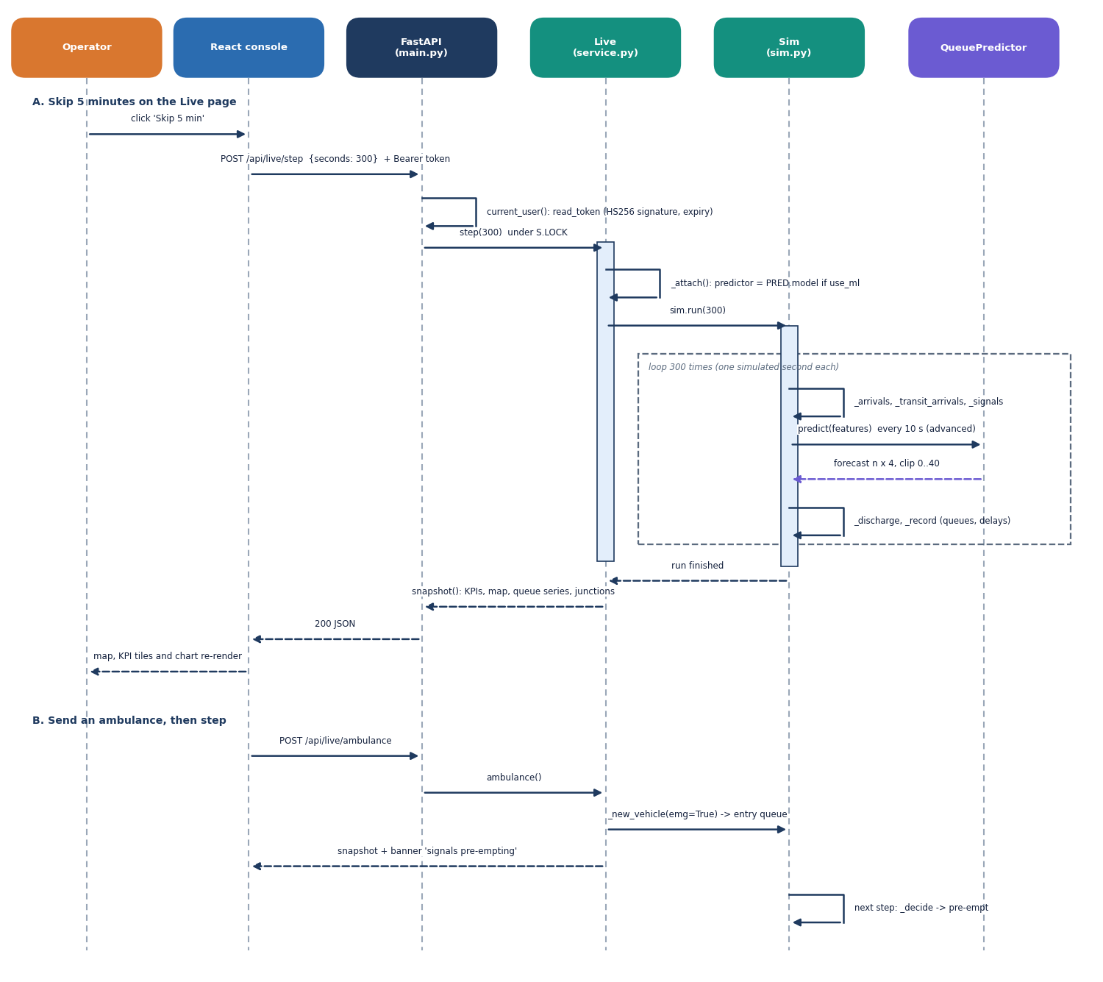
Figure 7: Sequence diagram of the main flow: (A) skip five minutes on the Live page; (B) send an ambulance and step again.
Scenario A starts when the operator clicks Skip 5 min. The React console sends POST /api/live/step {seconds: 300} with the bearer token; the API's current_user dependency checks the HS256 signature and expiry; Live.step runs under the service lock, attaches the forecaster if the ML toggle is on and calls Sim.run(300). Inside that call the simulator loops 300 times through arrivals, transit arrivals and signals, asks the forecaster for a prediction every 10 seconds (advanced controller) and finishes each second with discharge and record. The service then builds a snapshot (KPIs, map geometry, queue series, junction table) and the console redraws. In scenario B the operator sends an ambulance: Live.ambulance() creates an emergency vehicle at a random entry road and the snapshot carries the banner signals pre-empting; on the next step the simulator's decision step switches the affected junctions. The fixed-time and adaptive controllers instead give an "ignored" banner.

1.4.3 Use-case diagram
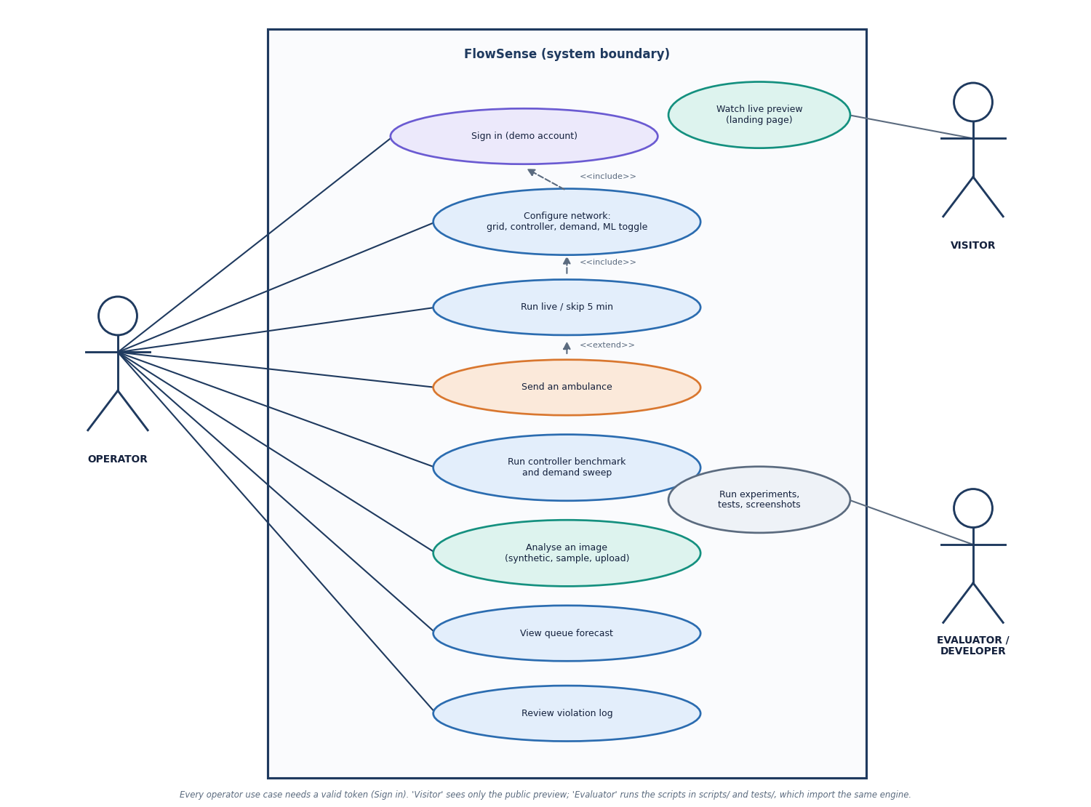
Figure 8: Use-case diagram with the operator, the visitor and the evaluator or developer.
The operator signs in with the demo account and can configure the network (grid, controller, demand, ML toggle), run the live simulation or skip five minutes, send an ambulance (an extension of running the simulation), run the controller benchmark and demand sweep, analyse an image (synthetic scene, sample photograph or upload), view the queue forecast and review the violation log. Every operator use case includes signing in. The visitor only watches the public live preview on the landing page, which needs no token. The evaluator or developer runs the experiment, test and screenshot scripts, which import the same engine. There is a single operator role in this build; the demo sign-in is a gate, not a role system.

1.5 Data Design
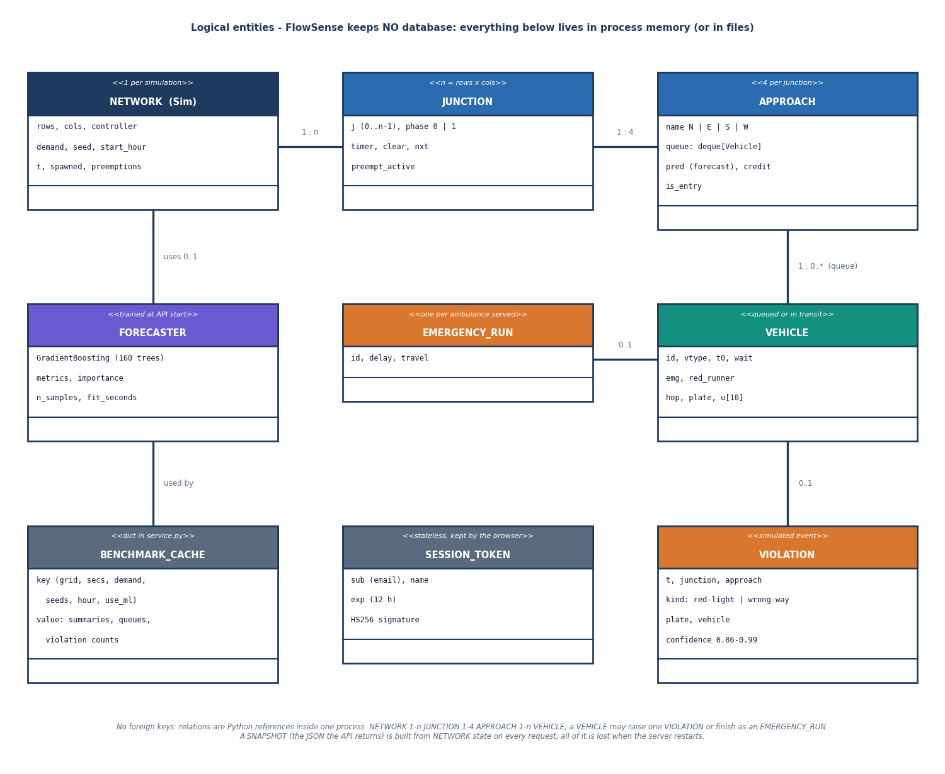
Figure 9: Logical entity-relationship diagram: FlowSense keeps its entities in memory; there is no database.
FlowSense stores no tables. The entity-relationship diagram is therefore logical: it shows which entities exist at run time and how they refer to one another. One NETWORK (the Sim) has n = rows x columns JUNCTIONs (1 : n); each junction has four APPROACHes (1 : 4); each approach holds a queue of zero or more VEHICLEs (1 : 0..*). A network uses at most one FORECASTER, which in turn is used by the BENCHMARK_CACHE; a vehicle may raise at most one VIOLATION or finish as an EMERGENCY_RUN if it is an ambulance; and the SESSION_TOKEN is stateless and kept by the browser. There are no foreign keys: the relations are Python references inside one process.
Table 3: In-memory entities.
Entity | Key attributes | Lifetime
Network (Sim) | rows, columns, controller, demand multiplier, seed, start hour, clock, spawned ambulances, pre-emptions | Until reset or API restart
Junction | index, phase (0 or 1), timer, clearance counter, next phase, pre-emption flag | Per simulation
Approach | name (N, E, S, W), queue of vehicles in arrival order, forecast, discharge credit, entry-road flag | Per simulation
Vehicle | id, type (car, bike, bus, truck, ambulance), arrival time, wait, emergency flag, red-runner flag, plate | Until it leaves the network
Violation event | time, junction, approach, kind, plate, vehicle type, confidence 0.86-0.99 | Per simulation
Emergency record | id, delay, travel time | Per simulation
Forecaster | GB model, metrics, importance, training row count | Until API restart (retrained in about 6 s)
Benchmark result | per-controller summaries for a settings key | Cached until restart
Token | subject, name, expiry (12 h), HS256 signature | Client side

Keeping state in memory was a choice, not an omission: the simulation is seeded and cheap to regenerate (a 30-minute run takes 0.17 to 0.52 s), the benchmark is deterministic for a given seed and settings, and the landing page's pulse does not need history. The cost is that nothing survives a restart and that the API serves one shared live simulation to every signed-in browser, which is acceptable for a single-operator demonstration and would not be for a deployment.

1.6 Core Algorithms

1.6.1 The advanced controller's decision
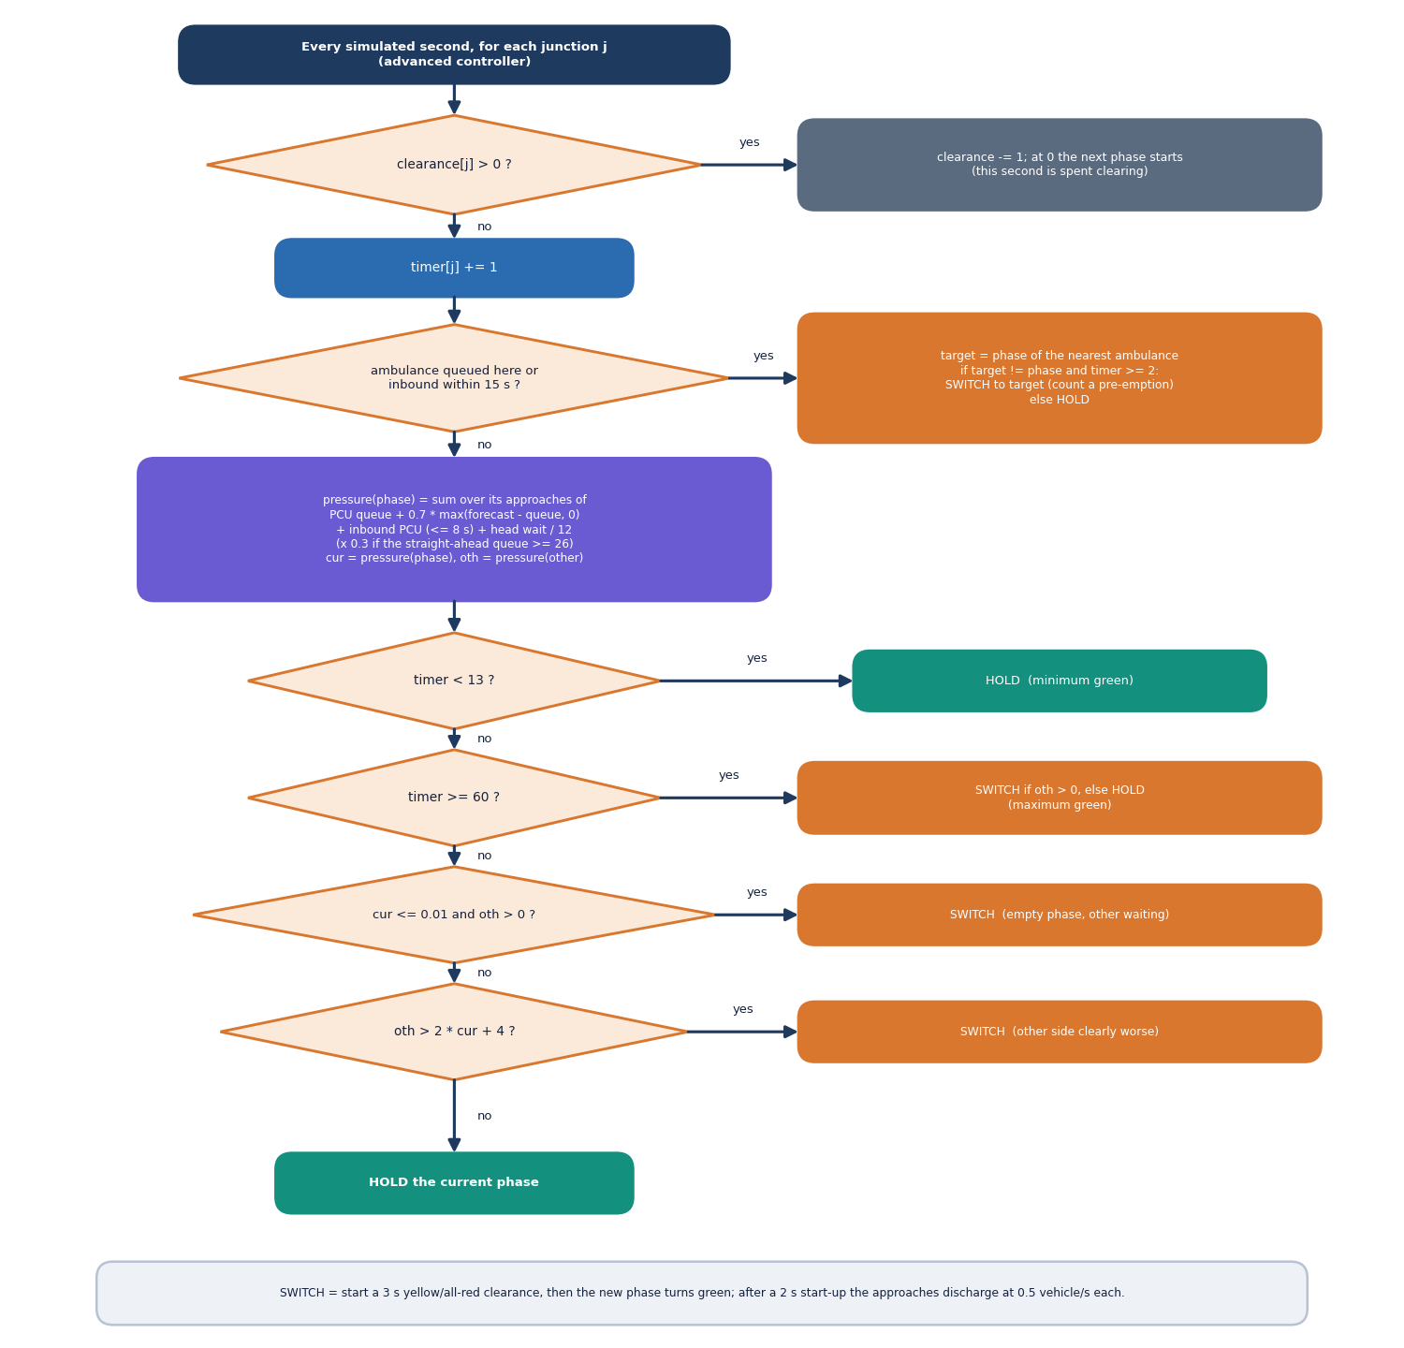
Figure 10: Flowchart of the advanced controller's per-junction decision, evaluated every simulated second.
Each junction has two phases (north-south and east-west). While a clearance interval is running nothing is decided. Otherwise the controller first checks for an emergency target: the nearest ambulance among queue heads and the inbound transit list within 15 seconds. If there is one and its phase is not green, the controller switches to it once the current green is at least 2 seconds old. If there is no emergency target, it compares the pressure of the green phase with that of the red phase. Pressure is the PCU-weighted queue, plus 0.7 times the forecast excess over the current queue, plus the PCU of vehicles arriving within 8 seconds, plus the head vehicle's wait divided by 12, and the result is multiplied by 0.3 for an approach whose straight-ahead receiving queue is nearly full. The green is kept for at least 13 seconds and at most 60; after the minimum the controller switches when the green phase has no pressure and the other has some, or when the other phase's pressure exceeds twice the current plus 4.
The other controllers are simplifications of the same loop: fixed switches every 30 seconds; adaptive uses the same switching rule with queue-only pressure and a 15 to 60 second green; emergency is adaptive plus pre-emption at the junction where the ambulance is queued or within 5 seconds. The emergency controller is an emulation of the base paper's idea [1], not a re-implementation, because the simulator knows which vehicles are ambulances and does not model a detector.

1.6.2 The vision pipeline
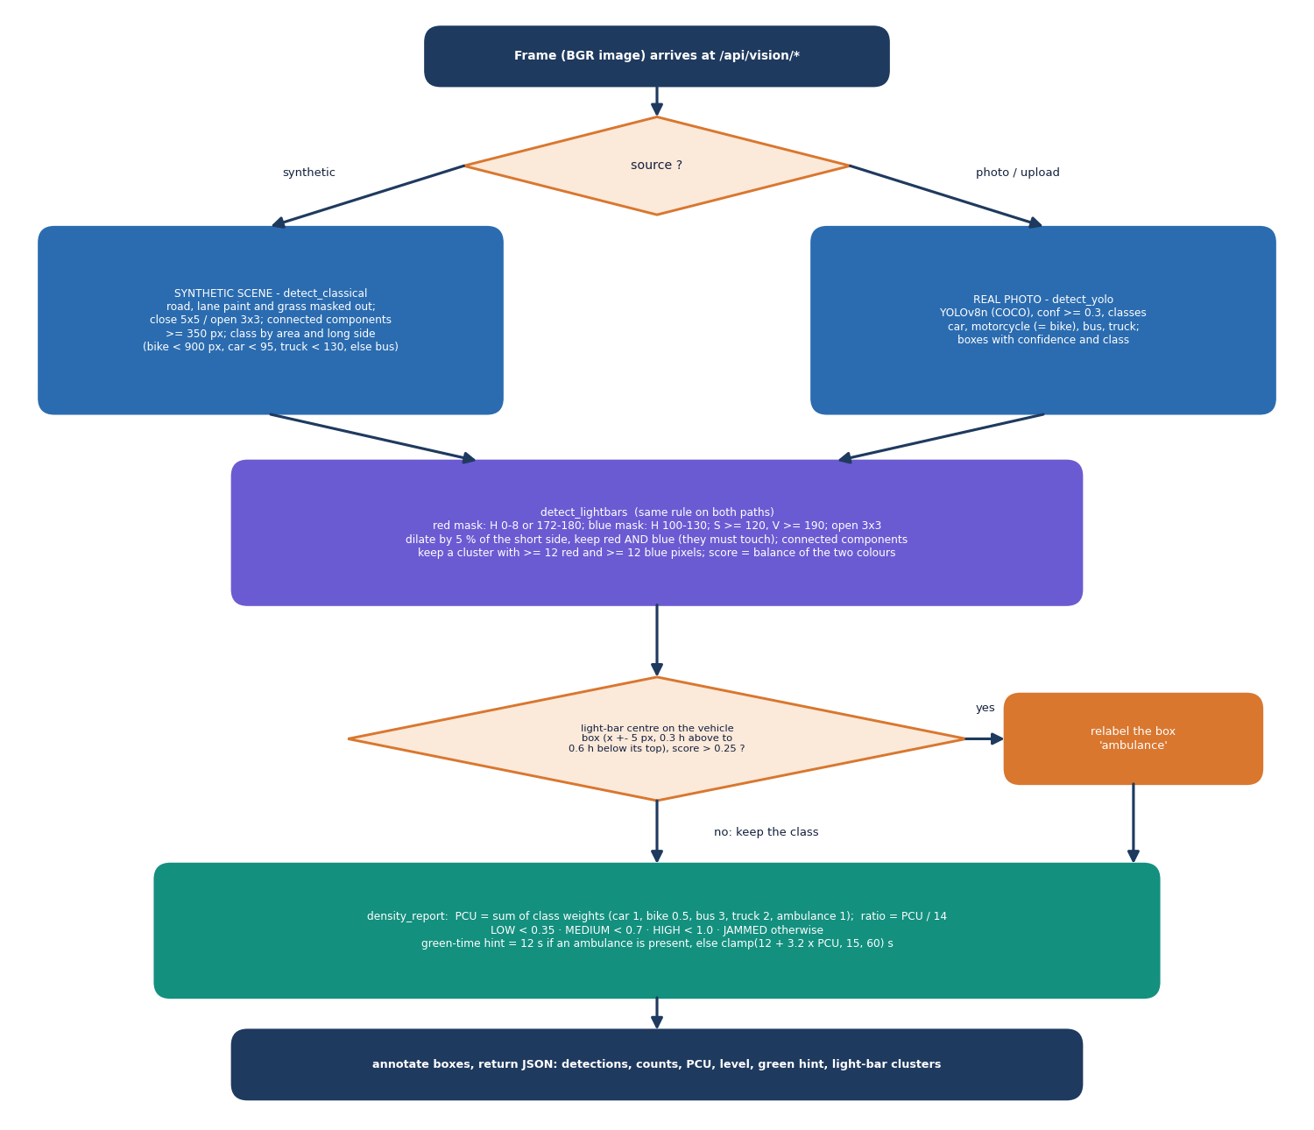
Figure 11: Flowchart of the vision pipeline: frame, vehicle detection, light-bar rule, density estimate and green-time recommendation.
For a real image the pipeline runs YOLOv8n [22] restricted to the COCO classes car, motorcycle, bus and truck [23], then an HSV rule finds red and blue blobs that touch after dilation. A detected vehicle whose box contains a light-bar cluster in its upper region is relabelled ambulance. The density report converts counts to passenger-car units (car 1, bike 0.5, bus 3, truck 2), divides by a road capacity of 14 PCU, labels the ratio LOW, MEDIUM, HIGH or JAMMED, and recommends 12 seconds of green if an ambulance is present, otherwise 12 + 3.2 per PCU clamped to 15 to 60 seconds. For the synthetic overhead scenes a contour-based classical detector replaces YOLO because the overhead renderer is outside COCO's training distribution.

1.6.3 The queue forecaster
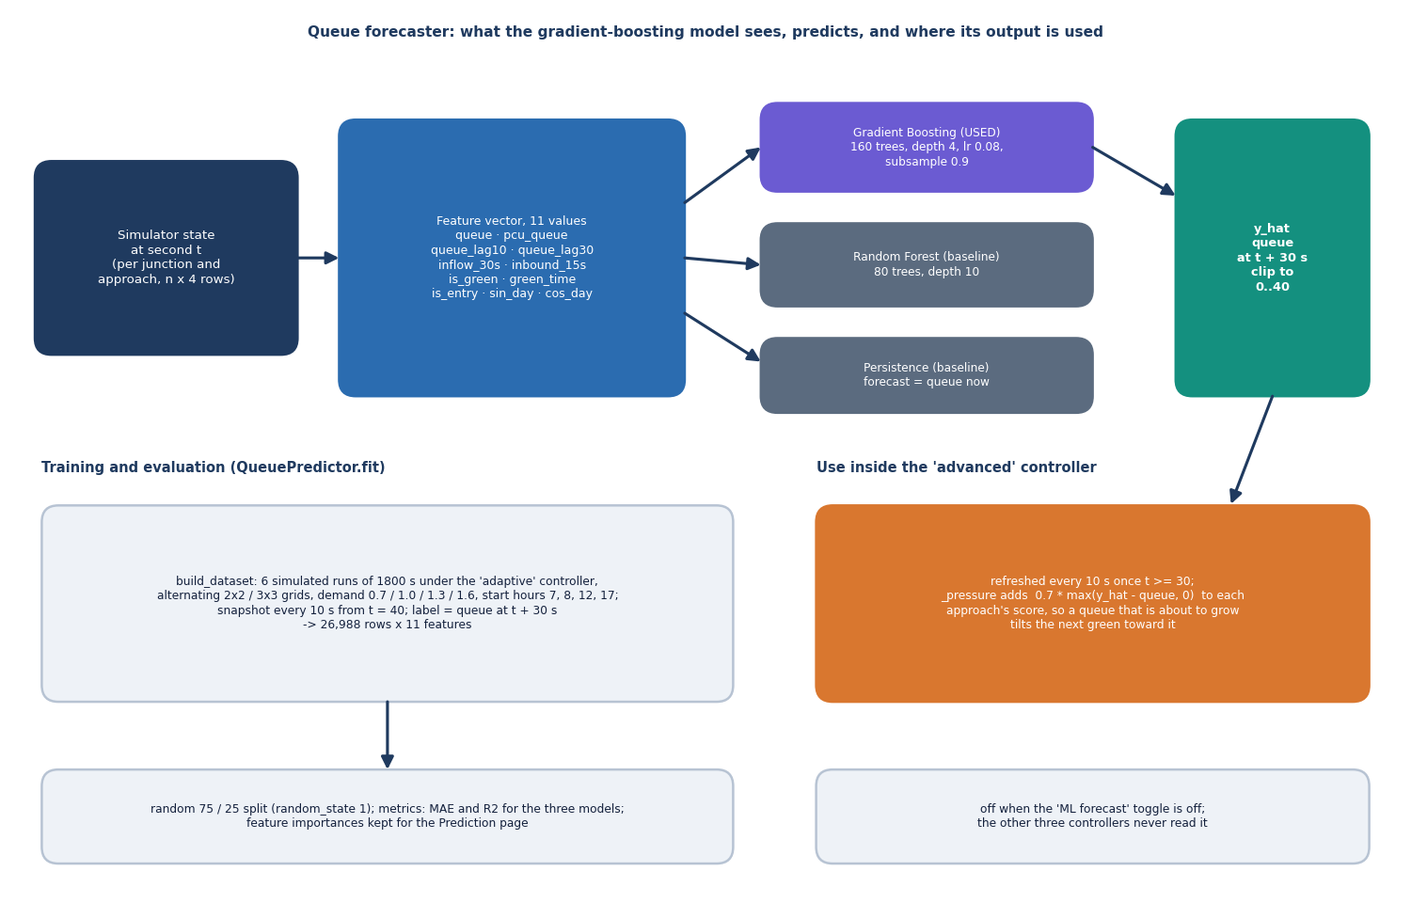
Figure 12: Architecture of the queue forecaster: 11 features per approach, gradient-boosted regressor, baselines and closed-loop use in the controller.
The forecaster predicts the queue length of each approach 30 seconds ahead from eleven features: the current queue, its PCU weight, the queue 10 and 30 seconds ago, the arrivals in the last 30 seconds, the vehicles inbound within 15 seconds, whether the approach is green, the green time so far, whether it is an entry road, and the sine and cosine of the time of day. It is a scikit-learn GradientBoostingRegressor [28], [30] of 160 trees, depth 4, learning rate 0.08 and subsample 0.9, trained on 26,988 snapshots from six simulated runs, with a Random Forest [29] and a persistence baseline ("the queue stays the same") for comparison. The advanced controller calls it every 10 simulated seconds and clips the output to 0 to 40 vehicles.

1.6.4 Cost of one simulated second
The simulator's cost is linear in the number of junctions and vehicles. Arrivals touch only the entry roads; the transit step touches the vehicles landing in that second; the signal step evaluates two phase pressures per junction, each a sum over two queues; the discharge step releases at most a few vehicles per approach; the record step walks every queue once to add a second of waiting time. The advanced controller adds an upstream scan of the next 15 seconds of the transit list and, every tenth second, one forecaster call on a 16 x 11 or 36 x 11 matrix. Measured on the test machine, 1,800 simulated seconds take 0.17 s (2 x 2, fixed-time) to 0.52 s (3 x 3, advanced), which is 3,473 to 10,871 times faster than real time; this is what makes five-seed benchmarks interactive.
Table 4: Order of events inside one simulated second (Sim.step).
Step | Method | What happens
1 | _arrivals | Poisson arrivals at entry roads scaled by demand and time of day; wrong-way driver draw; possible ambulance at a random entry road
2 | _transit_arrivals | Vehicles whose 12 s link time ends join their next approach queue
3 | _signals | Advanced or emergency-aware controllers scan upstream; the advanced one refreshes forecasts every 10 s; each junction advances its clearance or evaluates _decide
4 | _discharge | Green approaches release vehicles at saturation flow (ambulance first); red-light runners may cross; spill-back blocks release
5 | _record | Queue and arrival histories, total queue and phase log are appended; every queued vehicle's wait grows by 1 s

1.7 Module Design
Table 5: Modules, responsibilities and size.
Module | Lines | Responsibility
smart_traffic/sim.py | 415 | Simulator, demand profile, four controllers, features, KPIs, benchmark helper
smart_traffic/predictor.py | 59 | Dataset builder and the gradient-boosted queue forecaster with baselines
smart_traffic/vision.py | 201 | YOLOv8 wrapper, light-bar rule, classical detector, density report, annotation, synthetic scene
backend/main.py | 210 | FastAPI routes, input models, error handlers, authentication dependency
backend/service.py | 437 | Live, Preview and Predictor classes, benchmark and sweep, vision payloads, prediction and violation payloads
backend/auth.py, config.py | 55 + 32 | Stdlib HS256 token, credential check, .env settings
frontend/src/pages/*.jsx | 8 pages | Landing, Login, Live, Benchmark, Vision, Prediction, Violations, About
frontend/src/lib/* | - | Authentication context, live-simulation provider, theme, activity log, request hook
scripts/ | - | run_experiments, eval_real_vision, measure_api, smoke_test, capture_screens, check_ui, docs builders
tests/ | 2 files | 38 pytest tests (24 engine, 14 API)
app.py | 546 | Original Streamlit application, unchanged

The dependency direction is strictly downward: the React pages call /api, main.py calls service.py, service.py calls smart_traffic, and smart_traffic imports only NumPy, scikit-learn, OpenCV and, optionally, Ultralytics. No engine module imports FastAPI, so the engine can be tested without a server, as the 24 engine tests do.

1.8 API Design
The API has twenty endpoints in four groups. Four are public (health, login, the demo account for the sign-in page and the landing pulse); the other sixteen require a bearer token. Requests and responses are JSON, except the image upload, which is multipart. Errors always have the shape {detail: {message, hint}}, so the console can say what failed and what to do. Chapter 6 lists every endpoint with its request and response.
Table 6: Route groups.
Group | Routes | Purpose
Public | GET /api/health; POST /api/auth/login; GET /api/auth/demo; GET /api/public/pulse | Liveness and predictor state; sign-in; demo credentials; landing-page preview
Live control | GET /api/live; PUT /api/live/config; POST /api/live/step; /ambulance; /reset | The shared simulation
Benchmark | POST /api/benchmark; POST /api/benchmark/sweep | Four controllers on identical traffic; delay against demand
Vision, forecast, violations | GET /api/vision/synthetic, /sample; POST /api/vision/analyze; GET /api/prediction, /live; POST /api/prediction/simulate; GET /api/violations | Detections and density; forecasts; evidence log

1.9 User Interface Design
The console follows a control-room metaphor: a dark theme with a light option, a monospaced typeface for readings, and a left navigation with keyboard shortcuts (G then C, B, V, P, R, A) and a command palette on /. The sign-in page shows the demo account so that a reviewer never has to look for credentials. Every screen loads real data from the API; an error from the API is shown with its hint, and a model that is still training is shown as a state, not a blank panel.
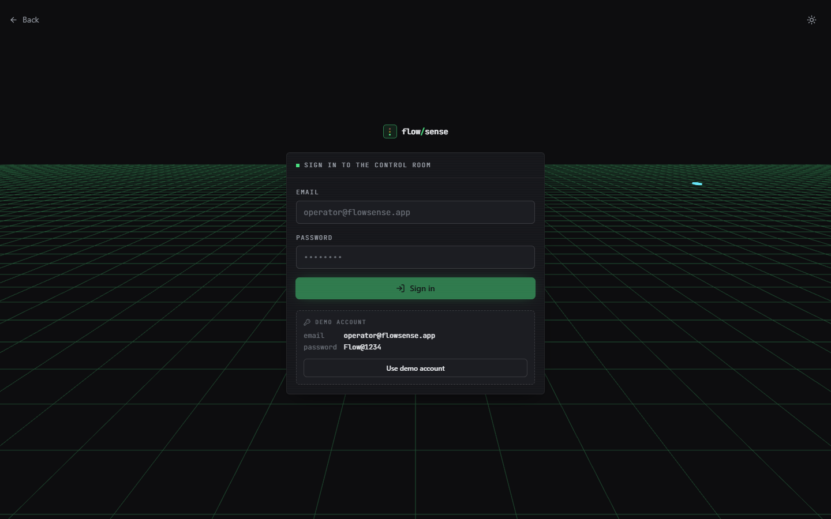  Figure 13: Sign-in page with the demo account. | 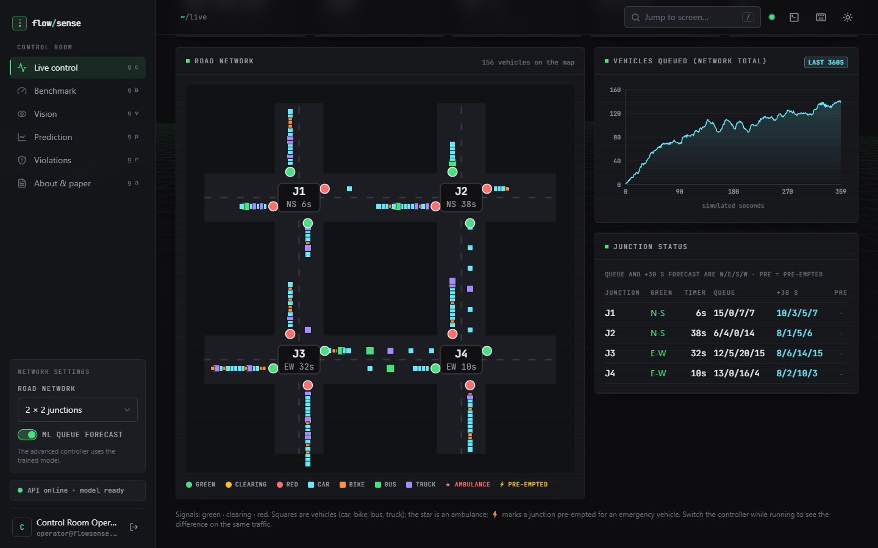  Figure 14: Live control: road map, queue chart and junction table.

Table 7: Screens and what each shows.
Screen | Route | Main content
Landing | / | Live preview map, headline numbers, event lines, feature overview
Sign in | /login | Credentials and the demo account
Live control | /app | Network settings, KPIs, road map with signals and vehicles, queue chart, junction status, ambulance button
Benchmark | /app/benchmark | Duration, demand, seeds and start hour; four-controller KPIs, delay and ambulance-delay charts, demand sweep
Vision | /app/vision | Synthetic scene, YOLOv8 sample photo and upload; detections, light-bar clusters, density report
Prediction | /app/prediction | Forecaster KPIs, predicted-against-actual scatter, importance, model comparison, live forecast
Violations | /app/violations | Counts, per-junction and per-minute charts, evidence log
About | /app/about | The paper, the pipeline and the project team

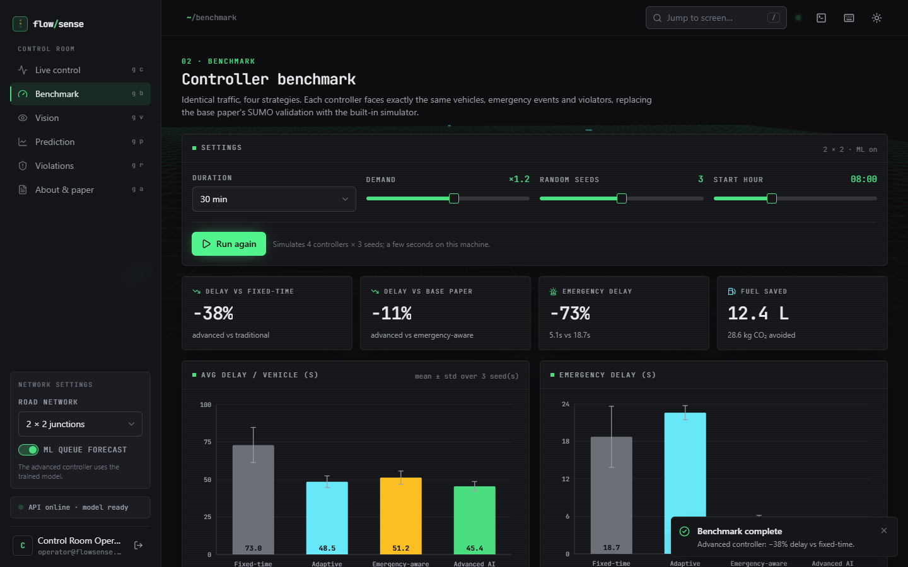  Figure 15: Benchmark screen with KPI tiles and charts. | 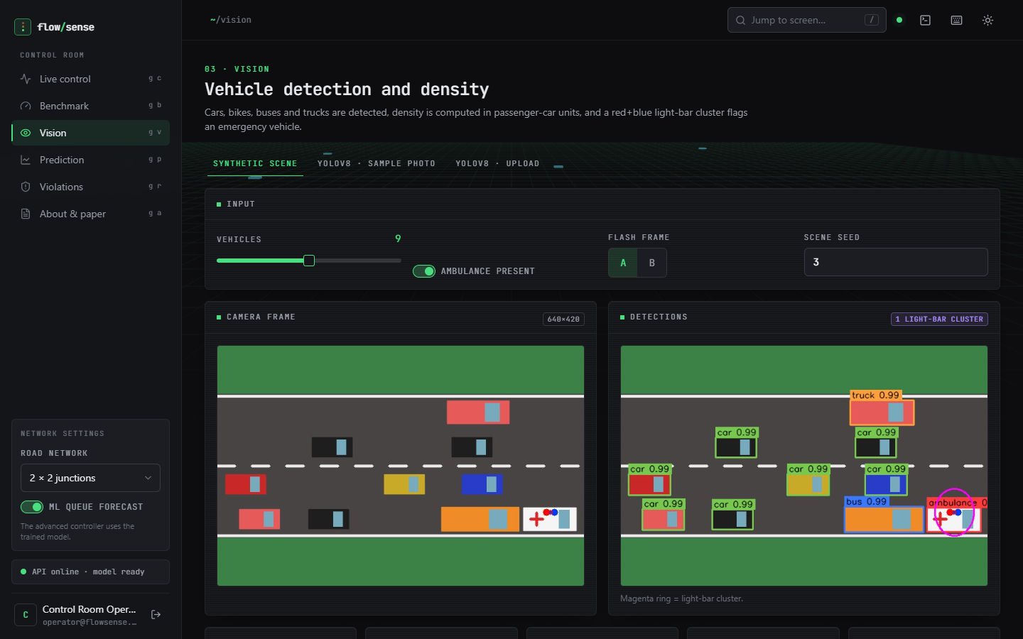  Figure 16: Vision screen on a synthetic scene.

The layout works from 360 px to 1440 px, honours reduced-motion settings, and keeps the state of the live simulation in a provider so that moving between screens does not reset it; scripts/check_ui.py exercises these cases in a real browser.

1.10 Traceability to the Project Objectives
The batch's six objectives (file 6, Objectives and Problem Statement) are each realised by a design element, and the table states plainly how far.
Table 8: Objectives, design elements and what was delivered.
Objective | Design element | Delivered
1. Detect and count vehicles from camera video with YOLO | detect_yolo (YOLOv8n) and detect_classical; Vision screen | Single frames and uploads only; no live video ingestion; stock COCO weights
2. Estimate density per approach | density_report (PCU / 14 capacity) for images; per-approach queue and PCU in the simulator | Yes, per image and per simulated approach; not wired from camera to simulator
3. Adaptive signal timing in proportion to demand | _pressure and _decide of the adaptive and advanced controllers | Yes, in simulation
4. Emergency priority | _emergency_target, upstream scan, lane clearing; light-bar rule for images | Yes in simulation with ground-truth ambulances; the image rule is not closed-loop
5. Coordination between adjacent junctions | Transit look-ahead, spill-back damping, green wave | Yes, as simulated look-ahead; not a network protocol
6. Evaluate detection accuracy, waiting time and emergency clearance | run_experiments.py, eval_real_vision.py, benchmark screen | Yes; see Chapter 8

1.11 Design Trade-offs
• Own simulator instead of SUMO. A pure-Python simulator is portable and fast (1,800 simulated seconds in 0.17 to 0.52 s) and keeps the experiment reproducible, but it is a model whose assumptions the project chose; absolute numbers cannot be compared with the base paper's SUMO study.
• Ground-truth emergency knowledge. The controllers know which vehicle is an ambulance; this isolates the control question from the detection question, at the price of not testing detection inside the loop.
• Pretrained detector, no training. YOLOv8n is used as shipped, which avoids a training pipeline and a dataset the batch did not have, and is the reason real-image accuracy is modest (Chapter 8).
• In-memory state. Simpler and enough for a demonstration; unsuitable for more than one operator or for restarts.
• Forecast as a pressure term, not a controller. The forecaster adds to the pressure score rather than replacing the rule, so a poor forecast can only bias the decision slightly, which is consistent with the ablation result that removing it costs about 3 s of delay.

2. IMPLEMENTATION

2.1 Application architecture
FlowSense runs as two processes. The API is a FastAPI application served by Uvicorn on 127.0.0.1:8310; the console is a React 19 single-page application built with Vite 8 and Tailwind 4 and served by the Vite development server on port 5310, which proxies /api to the API. The API's three layers are the route layer (backend/main.py, 210 lines: input models, error handlers, the authentication dependency), the service layer (backend/service.py, 437 lines: the live simulation, the landing preview, the predictor wrapper, benchmark, vision and violation payloads) and the engine (smart_traffic/). The service layer holds one threading.RLock; every route that touches the shared live simulation takes it, while benchmark and sweep routes build their own simulators and do not.
Figure 17: Layered architecture of FlowSense.
Start-up. S.start_background() launches a daemon thread that trains the forecaster (about 6 s) and then runs one 900 s fixed-time and one advanced simulation to compute the headline numbers shown on the landing page. Until training ends, routes that need the forecaster answer 503 with a hint to retry, and /api/health reports predictor_ready. Import order. backend/main.py imports PyTorch first because, on Windows, PyTorch's DLLs fail to initialise (error 1114) if NumPy, pandas or OpenCV are already loaded.
Live simulation. Live owns one Sim (2 x 2, advanced, demand 1.0, seed 7). Configuration changes (grid, controller, demand, emergencies, ML toggle) take effect immediately; changing the grid restarts the simulation. step(seconds) runs the engine and snapshot() returns the clock, KPIs, a banner ("signals pre-empting" or "this controller ignores it"), the map geometry (roads, signal states, one square per vehicle) and the junction table. The console's "Run live" button simply repeats two-second steps and redraws.
Benchmark. The benchmark route runs each of the four controllers over the requested seeds (seed = 40 + i), averages the summaries, computes the percentage changes shown as KPI tiles, caches the result by its settings and stores the violation counts for the Violations screen. The first request with four controllers, three seeds and 1,800 s takes about 4.8 s; a repeat is served from the cache in about 12 ms.
Console. The React application lazy-loads its eight pages and wraps the signed-in area in a LiveProvider, which holds the latest live snapshot, a busy flag and a version counter. Moving between screens therefore does not restart the simulation; a change made by another screen (the Prediction screen can advance the live simulation by 180 s) bumps the version so that the Live screen refreshes. api.js adds the token to every request, logs each call and its duration to an on-screen activity panel, and signs the user out on a 401. The road map is drawn as SVG from the geometry in the snapshot, and charts use Recharts.
Table 9: Modules and their responsibilities.
Module | Responsibility
smart_traffic/sim.py | Vehicle and Sim classes; demand; four controllers; upstream scan; discharge with spill-back and violations; feature matrix; summary; benchmark helper
smart_traffic/predictor.py | Dataset builder and QueuePredictor (fit, predict, metrics, importance)
smart_traffic/vision.py | YOLO loader and detector; light-bar masks and clusters; classical detector; density report; annotate; synthetic scene renderer
backend/main.py | Routes, pydantic request models, JSON error handlers, bearer-token dependency, startup hook
backend/service.py | Live, Preview, Predictor; benchmark and sweep; vision payloads (base64 JPEG); prediction and violation payloads; ApiError
backend/auth.py, config.py | HS256 token creation and verification; credential check; .env loader with safe defaults
frontend/src | App routes (lazy-loaded pages), api.js (axios with token and error description), live-simulation provider, theme and activity log, UI components, SVG traffic map

2.2 API design
All routes are under /api. Four are public; the others need an Authorization: Bearer <token> header. Errors have the form {"detail": {"message": ..., "hint": ...}} for every status code, including framework validation errors, which are rewritten by a handler so that the console never shows a raw stack trace.
Table 10: The twenty endpoints.
Method and path | Auth | Request | Response
GET /api/health | no | - | ok, predictor_ready, predictor_error, yolo_available, live_clock
POST /api/auth/login | no | {email, password} | token, user
GET /api/auth/demo | no | - | demo email and password for the sign-in page
GET /api/public/pulse | no | - | preview map, KPIs, up to 12 event lines, headline numbers
GET /api/auth/me | yes | - | name, email
GET /api/meta | yes | - | controllers, approaches, grids, vehicle types, version
GET /api/live | yes | - | live snapshot
PUT /api/live/config | yes | {grid, controller, demand 0.4-2.0, emergencies, use_ml} | live snapshot
POST /api/live/step | yes | {seconds 1-900} | live snapshot
POST /api/live/ambulance | yes | - | snapshot + entry {junction, approach}
POST /api/live/reset | yes | - | snapshot at t = 0
POST /api/benchmark | yes | {grid, seconds 300-3600, demand 0.5-1.8, seeds 1-5, start_hour 0-23, use_ml} | settings, KPIs, per-controller results, table
POST /api/benchmark/sweep | yes | {grid, use_ml} | levels 0.6-1.8, delay series per controller
GET /api/vision/synthetic | yes | ?vehicles 2-16, ambulance, flash A/B, seed | frame, annotated frame, detections, density report
GET /api/vision/sample | yes | ?conf | same, YOLOv8n on the bundled photo
POST /api/vision/analyze | yes | multipart file (≤ 12 MB), conf | same, YOLOv8n on the upload
GET /api/prediction | yes | - | KPIs, metrics, scatter (≤ 1,500 points), importance
GET /api/prediction/live | yes | - | per-approach queue now and forecast, worst approach
POST /api/prediction/simulate | yes | - | advances the live simulation 180 s; snapshot
GET /api/violations | yes | - | KPIs, by junction, per minute, log (≤ 300), last benchmark

Two design points are worth noting. The vision routes return both the original and the annotated image as base64 JPEG data URLs so that the console needs no second request. The benchmark route is a plain function of its settings, so it can be cached by key and the console can show a result instantly when the settings are unchanged.

2.3 Security and error handling
FlowSense is a demonstration console, not a hardened service, and its security is proportionate to that. Authentication is one configured operator account (DEMO_EMAIL, DEMO_PASSWORD in .env, defaulting to the account shown on the sign-in page). A successful login returns an HS256 token built from the standard library: a base64url header and payload (subject, name, expiry 12 hours ahead) and an HMAC-SHA256 signature. The signature and the credentials are compared with hmac.compare_digest; a tampered or expired token is rejected with 401, and the console then clears its stored token and returns to the sign-in page.
• Signing key. JWT_SECRET from .env is used only if it has at least 32 characters and is not the generate-... placeholder; otherwise a fixed development key in the source is used, which is acceptable for a local demo and unsafe anywhere else.
• Input validation. Request bodies are pydantic models with bounds (demand 0.4-2.0, step 1-900 s, e-mail and password length); benchmark settings are range-checked and answer 422 with the allowed ranges; an unknown grid or controller answers 422 naming the valid values.
• Uploads. The image route reads at most 12 MB + 1 byte and answers 413 beyond 12 MB; a file that OpenCV cannot decode answers 415 asking for a JPG or PNG frame.
• Missing or failing components. Without ultralytics the YOLO routes answer 503 with the install command; if YOLO raises (for example the first run cannot download yolov8n.pt offline) the answer is 502 with the exception text; while the forecaster trains, forecast-dependent routes answer 503; if training failed they answer 500 with the reason.
• Error shape. One handler each for the service's ApiError, for HTTPException and for request validation produce the same {message, hint} JSON; the console's describeError shows both fields.
• Not done. There is no rate limiting, no HTTPS, no per-user data, no CSRF protection beyond bearer tokens, and no audit trail; the live simulation is one shared object for every signed-in browser.
The 14 API tests and the 33 smoke checks (Chapter 7) exercise the 401, 422, 413/415 and 503 paths.

2.4 Installation and execution
run.bat starts the whole application on Windows: it creates .venv if needed (and rebuilds it if it points at a missing Python), installs backend/requirements.txt (FastAPI, Uvicorn, NumPy, pandas, scikit-learn, OpenCV, python-multipart) and then backend/requirements-yolo.txt (Ultralytics and PyTorch, a large download; if it fails the application still runs and only the YOLO modes of the Vision page are unavailable), runs npm install in frontend/ on first use, starts the API on port 8310 and the Vite server on port 5310 in two minimised windows, and opens the browser. run.bat nobrowser skips the browser.
Table 11: Requirements and settings.
Item | Value
Python / Node | Python 3.10 or newer (3.11.9 used here); Node 20 or newer (24.19 used here)
Key packages (as run) | FastAPI 0.143.3, scikit-learn 1.5.0, NumPy 1.26.4, pandas 2.2.1, OpenCV 4.11.0, Ultralytics 8.4.186, PyTorch 2.14.1 (CPU), React 19, Vite 8
.env keys | BACKEND_PORT 8310, FRONTEND_PORT 5310, DEMO_EMAIL, DEMO_PASSWORD, DEMO_NAME, JWT_SECRET (a Gemini key entry in .env.example is unused by this product)
Hardware used | Intel Core i5-12500 (6 cores / 12 threads), 15.7 GB RAM, no CUDA GPU; everything runs on the CPU
Verification | python -m pytest tests (38 tests); python scripts/smoke_test.py http://127.0.0.1:8310 (33 checks); python scripts/measure_api.py
Reproduce the results | python scripts/run_experiments.py (about 2 minutes); python scripts/fetch_real_images.py then python scripts/eval_real_vision.py (about 1 minute); python scripts/make_report_facts.py

By hand: create a virtual environment, install the two requirements files, run python -m uvicorn backend.main:app --port 8310 from 8.ProjectCode, then npm install and npm run dev inside frontend/. Appendix B gives the full user guide. Measurements in this report were taken against 127.0.0.1 rather than localhost, because on the test machine name resolution of localhost added about two seconds per client call.

2.5 Reproducibility
Every number in this report can be regenerated. scripts/run_experiments.py writes one metrics.json per experiment under experiments/; scripts/fetch_real_images.py downloads the two public image sets into the git-ignored data/external/; scripts/eval_real_vision.py and scripts/measure_api.py write the vision and latency files; scripts/make_report_facts.py turns all of them into docs/REPORT_FACTS.md, and the documentation build reads the same JSON files, so no result is typed into the text by hand. All randomness is seeded (demand by the simulation seed, the forecaster's trees by random_state), so results are identical on repeated runs; only wall-clock timings vary with machine load.

3. KEY CODE WALK-THROUGHS

3.1 The advanced controller's decision rule (`sim.py`)
_decide is called once per second for each junction that is not in its clearance interval. Emergency pre-emption comes first; otherwise the pressure of the current phase and of the other phase are compared, subject to the minimum and maximum green times.
def _decide(self, j):
ph, tm, ctrl = self.phase[j], self.timer[j], self.controller
if ctrl == "fixed":
return 1 - ph if tm >= FIXED_GREEN else ph
if ctrl in ("emergency", "advanced"):
target = self._emergency_target(j)
if target is not None:
if target != ph and tm >= 2:
self.preemptions += 0 if self._preempt_active[j] else 1
self._preempt_active[j] = True
return target
self._preempt_active[j] = target == ph
return ph
self._preempt_active[j] = False
adv = ctrl == "advanced"
cur, oth = self._pressure(j, ph, adv), self._pressure(j, 1 - ph, adv)
min_g, max_g = (13, 60) if adv else (MIN_GREEN, MAX_GREEN)
if tm < min_g:
return ph
if tm >= max_g:
return 1 - ph if oth > 0 else ph
if cur <= 0.01 and oth > 0:
return 1 - ph
if oth > 2.0 * cur + 4:
return 1 - ph
return ph

def _emergency_target(self, j):
best_dt, best_ph = 99, None
for a in range(4):
if any(v.emg for v in self.q[j][a]):
dt = 0
else:
dt = self._emg_in.get((j, a), 99)
if dt < best_dt:
best_dt, best_ph = dt, PHASE_OF[APPROACHES[a]]
return best_ph

If an ambulance is waiting at the junction or arriving within the look-ahead (_emergency_target), its phase is forced after at least 2 s of the current green (the clearance interval of 3 s follows automatically). Otherwise the junction stays in its phase until the minimum green (13 s for the advanced controller, 15 s for the others), and switches when the current phase is empty and the other has demand, when the other pressure exceeds twice the current pressure plus four, or at the 60 s maximum.

3.2 Pressure, forecast and spill-back (`_pressure`)
def _pressure(self, j, phase, adv):
total = 0.0
for a, name in enumerate(APPROACHES):
if PHASE_OF[name] != phase:
continue
qq = self.q[j][a]
w = self.wq(j, a)
if adv:
w += 0.7 * max(float(self.pred[j, a]) - len(qq), 0.0) # ML forecast
w += float(self._inbound[j, a]) # arriving platoon
if qq:
w += qq[0].wait / 12.0 # fairness
nh = self._next_hop_of_straight(j, a)
if nh is not None and len(self.q[nh[0]][nh[1]]) >= CAP - 4:
w *= 0.3 # downstream full
total += w
return total

For the advanced controller the pressure of each approach is the PCU-weighted queue plus 0.7 times the forecast build-up (forecast queue minus queue now, never negative), plus the passenger-car units due within 8 s from the upstream junction, plus the head-of-queue waiting time divided by 12 s as a fairness term; the whole is multiplied by 0.3 when the straight-ahead downstream approach is within four vehicles of its capacity, which is the spill-back avoidance. The adaptive controllers use the PCU queue alone. The constants 0.7, 8, 12 and 0.3 were chosen by hand, not fitted.

3.3 The forecaster (`predictor.py`)
def build_dataset(seeds=(1, 2, 3, 4, 5, 6), seconds=1800, demands=(0.7, 1.0, 1.3, 1.6)):
X, y = [], []
for k, s in enumerate(seeds):
rows, cols = (2, 2) if k % 2 == 0 else (3, 3)
sim = Sim(rows, cols, "adaptive", demands[k % len(demands)], seed=100 + s,
start_hour=[7.0, 8.0, 12.0, 17.0][k % 4], emergencies=False, violations=False)
snaps = []
for t in range(seconds):
sim.step()
if t >= 40 and t % 10 == 0:
snaps.append((t, sim.feature_matrix()))
for t, F in snaps:
if t + HORIZON < seconds:
X.append(F)
y.append(sim.qhist[t + HORIZON].reshape(-1))
return np.vstack(X), np.concatenate(y)
...
class QueuePredictor:
"""Gradient-boosted regressor with RandomForest and persistence baselines."""

def __init__(self):
self.model = GradientBoostingRegressor(n_estimators=160, max_depth=4, learning_rate=0.08,
subsample=0.9, random_state=0)
self.metrics = {}
self.test = None

def fit(self, X=None, y=None):
if X is None:
X, y = build_dataset()
Xtr, Xte, ytr, yte = train_test_split(X, y, test_size=0.25, random_state=1)
self.model.fit(Xtr, ytr)
rf = RandomForestRegressor(n_estimators=80, max_depth=10, random_state=0, n_jobs=-1).fit(Xtr, ytr)
pred_gb, pred_rf, persist = self.model.predict(Xte), rf.predict(Xte), Xte[:, 0]
self.metrics = {
"Persistence baseline": (mean_absolute_error(yte, persist), r2_score(yte, persist)),
"Random Forest": (mean_absolute_error(yte, pred_rf), r2_score(yte, pred_rf)),
"Gradient Boosting (used)": (mean_absolute_error(yte, pred_gb), r2_score(yte, pred_gb)),
}
self.test = (yte, pred_gb)
self.importance = dict(zip(Sim.FEATURES, self.model.feature_importances_))
self.n_samples = len(y)
return self

Training data is generated by running the simulator under the adaptive controller and storing the 11-feature matrix every 10 s from t = 40 s, labelled with the queue 30 s later. A gradient-boosting regressor (160 trees, depth 4, learning rate 0.08, subsample 0.9) is fitted on a random 75 % of the rows and compared with a random forest and with persistence on the other 25 %. The random split is the weakness identified in Chapter 8: rows from one simulation are near-duplicates, so the reported R2 is optimistic.

3.4 The light-bar rule and density report (`vision.py`)
def detect_lightbars(bgr, min_area=12):
"""Find red+blue emergency light-bar clusters. Returns list of (x, y, w, h, score)."""
red, blue = lightbar_masks(bgr)
h, w = red.shape
dil = max(3, int(min(h, w) * 0.05))
kern = np.ones((dil, dil), np.uint8)
# a light bar = red and blue blobs touching after dilation
both = cv2.dilate(red, kern) & cv2.dilate(blue, kern)
n, _, stats, _ = cv2.connectedComponentsWithStats(both)
out = []
for i in range(1, n):
x, y, bw, bh, area = stats[i]
rr = int(np.count_nonzero(red[y:y + bh, x:x + bw]))
bb = int(np.count_nonzero(blue[y:y + bh, x:x + bw]))
if rr >= min_area and bb >= min_area:
score = min(1.0, 2 * min(rr, bb) / (rr + bb) * min(1.0, (rr + bb) / 120))
out.append((int(x), int(y), int(bw), int(bh), float(score)))
return out
...
def density_report(dets, road_capacity_pcu=14):
counts = {k: 0 for k in PCU}
for d in dets:
counts[d["cls"]] += 1
pcu = sum(PCU[k] * n for k, n in counts.items())
ratio = pcu / road_capacity_pcu
level = "LOW" if ratio < 0.35 else "MEDIUM" if ratio < 0.7 else "HIGH" if ratio < 1.0 else "JAMMED"
emg = counts["ambulance"] > 0
green = 12 if emg else int(min(60, max(15, 12 + 3.2 * pcu)))
return dict(counts=counts, pcu=pcu, ratio=ratio, level=level, emergency=emg, green=green)

Red and blue masks are taken in HSV, dilated and intersected so that only red and blue blobs that touch survive; each cluster gets a score from the balance and amount of red and blue pixels. A detected vehicle box becomes an ambulance when a cluster lies on its upper part with score above 0.25. density_report sums PCU, divides by an assumed capacity of 14 PCU, names the level and recommends a green time of 12 s if an ambulance is present and otherwise 12 + 3.2 times the PCU, clamped to 15-60 s.

3.5 Serving a benchmark (`service.py`)
def benchmark(grid, secs, dem, nseeds, start_h, use_ml) -> dict:
if grid not in GRIDS:
raise ApiError(422, f"Unknown road network '{grid}'.", "Use 2x2 or 3x3.")
if not (300 <= secs <= 3600 and 0.5 <= dem <= 1.8 and 1 <= nseeds <= 5 and 0 <= start_h <= 23):
raise ApiError(422, "Benchmark settings are out of range.", "Duration 5-60 min, demand 0.5-1.8, 1-5 seeds, start hour 0-23.")
pred = need_predictor() if use_ml else None
key = (grid, secs, round(dem, 2), nseeds, start_h, use_ml)
if key in _BENCH_CACHE:
res = _BENCH_CACHE[key]
else:
rows, cols = GRIDS[grid]
res = {}
for c in CONTROLLERS:
sums, q, emg, viol = [], [], [], []
for s in range(nseeds):
sm = Sim(rows, cols, c, dem, seed=40 + s, start_hour=start_h, predictor=pred if use_ml else None).run(secs)
sums.append(sm.summary())
q.append(sm.qtot)
emg += sm.emg_log
viol += sm.viol_log
res[c] = dict(sums=pd.DataFrame(sums), q=np.mean(q, axis=0), emg=emg, viol=viol)
_BENCH_CACHE[key] = res
mean = pd.DataFrame({c: r["sums"].mean() for c, r in res.items()}).T
base, paper, ours = mean.iloc[0], mean.iloc[2], mean.iloc[3]
d_fixed = 100 * (1 - ours["Avg delay / vehicle (s)"] / max(base["Avg delay / vehicle (s)"], 1e-9))
d_paper = 100 * (1 - ours["Avg delay / vehicle (s)"] / max(paper["Avg delay / vehicle (s)"], 1e-9))
e_fixed = 100 * (1 - ours["Emergency delay (s)"] / max(base["Emergency delay (s)"], 1e-9))

The benchmark endpoint validates the request, checks the cache, then runs every controller for every seed with the same seeds (40 + i), so controllers see identical traffic. The advanced controller receives the shared trained predictor, and results are averaged over seeds before the key performance indicators are computed. Errors are raised as ApiError objects and rendered by one exception handler as {detail: {message, hint}}.

3.6 Token authentication (`auth.py`)
def make_token(email: str, name: str) -> str:
head = _b64(json.dumps({"alg": "HS256", "typ": "JWT"}).encode())
body = _b64(json.dumps({"sub": email, "name": name, "exp": int(time.time()) + config.TOKEN_HOURS * 3600}).encode())
return f"{head}.{body}.{_sign(head + '.' + body)}"

def read_token(token: str) -> dict | None:
try:
head, body, sig = token.split(".")
if not hmac.compare_digest(sig, _sign(head + "." + body)):
return None
data = json.loads(_unb64(body))
return data if data.get("exp", 0) > time.time() else None
except Exception:
return None

The sign-in token is a three-part HS256 token built with the standard library (hmac, hashlib, base64); verification compares signatures in constant time and rejects expired tokens. The signing key is read from .env and falls back to a development key if it is missing or a placeholder.

4. IMPLEMENTATION DECISIONS AND THEIR REASONS
The table lists the main implementation decisions with the reason for each and the consequence that was observed.
Table 12: Implementation decisions and their reasons
Decision | Reason | Consequence observed
Build a pure-Python simulator instead of using SUMO | Runs on any laptop with no installation, is seeded and deterministic, and lets four controllers run on identical demand in seconds (1800 s in 0.17-0.52 s) | Fast iteration and a like-for-like benchmark; absolute numbers cannot be compared with SUMO studies
Run all controllers on the same random demand | A fair comparison needs the same vehicles and ambulances; demand uses its own random stream independent of control | Differences between controllers are due to control; verified by a unit test
Two-phase signals | Keeps the state small and the pressure rule readable | No turn-specific phases; limits realism
PCU-weighted queues | A bus occupies more road than a motorbike; PCU weights 1, 0.5, 3, 2 follow common practice | Density and pressure account for vehicle mix
Gradient boosting for the forecaster | Strong on tabular features, small, trains in about 6 s at start-up, no GPU | Random forest was equally good (MAE 1.609 against 1.642); neither extrapolates beyond training queues
Train the forecaster on the adaptive controller's data | Avoids feedback from the advanced controller's own decisions | Used inside a different controller at run time, a small distribution shift
Clip forecasts to 0-40 vehicles | Prevents absurd values reaching the controller | Hides large errors on congested runs
Stock YOLOv8n with COCO weights | No labelled light-bar data in the batch; the model downloads automatically and runs on a CPU at about 32 ms per frame | Poor on two- and three-wheelers; no emergency class
HSV red-plus-blue light-bar rule | Simple, explainable, needs no training data; mirrors the base paper's cue | Perfect on synthetic scenes, 1.3 % recall on real photographs
Classical contour detector for synthetic scenes | YOLOv8n cannot see rendered rectangles; gives a demo path without a dataset | Brittle under noise; synthetic scores are in-domain only
Violations generated by the simulator | No labelled violation video available; shows the logging and evidence flow | Must be described as simulated, not detected
FastAPI with one shared live simulation | One operator console needs one shared state; state kept in process memory | No persistence; a restart creates a fresh simulation
Standard-library HS256 token and a demo account | No user database needed for a demonstration; keeps the install small | Not suitable for production
Predictor trains in a background thread at start-up | The API starts immediately; routes that need the model return 503 with a hint until it is ready | First use after start-up waits about 6-10 s
Cache benchmark results by request key | Repeat requests are free and the page feels instant | First run of four controllers by three seeds takes about 4.8 s
Measure on 127.0.0.1 | localhost adds about 2 s per call through an IPv6 fall-back on this machine | Latency figures reflect the application, not the resolver

